Table of Contents
What is a Transaction? 1
Evaluating Transaction Results 1
Transaction Properties 2
Transaction State 2
Transaction Management with SQL 3
Transaction Log 3
Concurrency Control 4
Lost updates 4
Uncommitted Data 5
Inconsistent Retrievals 5
The Scheduler – Schedule, Serializability, Recovery, Isolation 6
Concurrency Control with Locking Methods 9
Lock Granularity 9
Database-Level 9
Table-Level 9
Page-Level 9
Row-Level 10
Field-Level 10
Lock Types 10
Binary Locks 10
Shared/Exclusive Locks 10
Two-Phase Locking 11
Deadlocks 12
Implementation of Locking 13
Concurrency Control with Time Stamping Methods 13
Timestamp-Based Protocols 14
Concurrency Control with Optimistic Methods 15
Database Recovery Management 15
Transaction Recovery 16

What is a Transaction?
- A transaction is a logical unit of work –
It may consist of a simple SELECT to generate a list of table contents, or a series of related UPDATE command sequences.
A database request is the equivalent of a single SQL statement in an application program or transaction.
  - Must be either entirely completed or aborted –
To sell a product to a customer, the transaction includes updating the inventory by subtracting the number of units sold from the PRODUCT table’s available quantity on hand, and updating the accounts receivable table in order to bill the customer later.
  - No intermediate states are acceptable –
Updating only the inventory or only the accounts receivable is not acceptable.
- Example Transaction – (Refer Figure 1)
It illustrates a typical inventory transaction that updates a database table by subtracting 10 (units sold) from an already stored value of 40 (units in stock), which leaves 30 (units of stock in inventory).
  - A consistent database state is one in which all data integrity constraints are satisfied.
  - At this transaction is taking place, the DBMS must ensure that no other transaction access X.

Evaluating Transaction Results
- Examine current account balance
SELECT ACC_NUM, ACC_BALANCE
FROM CHECKACC
WHERE ACC_NUM = ‘0908110638’;
  - SQL code represents a transaction because of accessing the database
  - Consistent state after transaction
  - No changes made to Database
- Register credit sale of 100 units of product X to customer Y for $500:
Reducing product X’s quality on and (QOH) by 100
UPDATE PRODUCT
SET PROD_QOH = PROD_QOH - 100
WHERE PROD_CODE = ‘X’;
Adding $500 to customer Y’s accounts receivable
UPDATE ACCT_RECEIVABLE
SET ACCT_BALANCE = ACCT_BALANCE + 500
WHERE ACCT_NUM = ‘Y’;
- If both transactions are not completely executed, the transaction yields an inconsistent database.
- Consistent state only if both transactions are fully completed
- DBMS doesn’t guarantee transaction represents real-world event but it must be able to recover the database to a previous consistent state. (For instance, the accountant inputs a wrong amount.)

Transaction Properties
  - All transactions must display atomicity, durability, serializability, and isolation.
        - Atomicity –
    - All transaction operations must be completed
    - Incomplete transactions aborted
        - Durability –
    - Permanence of consistent database state
        - Serializability –
    - Conducts transactions in serial order
    - Important in multi-user and distributed databases
- Isolation –
      - Transaction data cannot be reused until its execution complete
        - Consistency – (To preserve integrity of data, the database system must ensure: atomicity, consistency, isolation, and durability (ACID).)
    - Execution of a transaction in isolation preserves the consistency of the database.
        - A single-user database system automatically ensures serializability and isolation of the database because only one transaction is executed at a time.
        - The atomicity and durability of transactions must be guaranteed by the single-user DBMS.
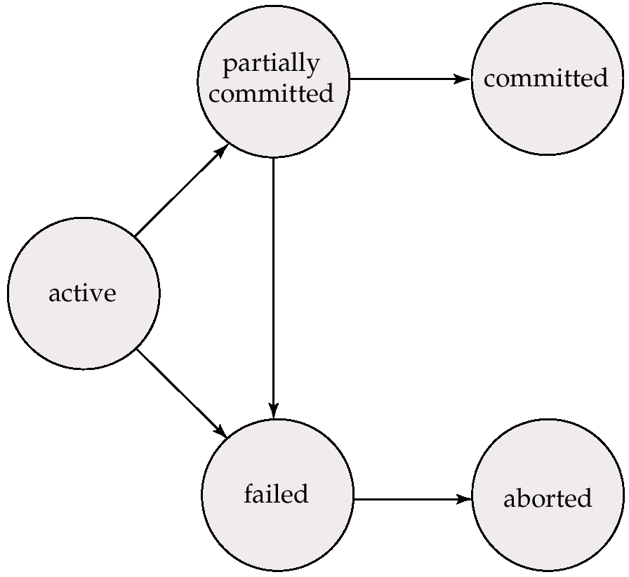
        - The multi-user DBMS must implement controls to ensure serializability and isolation of transactions – in addition to atomicity and durability – in order to guard the database’s consistency and integrity.

Transaction State
        - Active, the initial state; the transaction stays in this state while it is executing.
        - Partially committed, after the final statement has been executed.
        - Failed, after the discovery that normal execution can no longer proceed.
        - Aborted, after the transaction has been rolled back and the database restored to its state prior to the start of the transaction. Two options after it has been aborted:
          - Restart the transaction – only if no internal logical error but hardware or software failure.
          - Kill the transaction – once internal logical error occurs like incorrect data input.
        - Committed, after successful completion. The transaction is terminated once it is aborted or committed.

Transaction Management with SQL
- Defined by ANSI, the standards of SQL transaction support: COMMIT & ROLLBACK
- User initiated transaction sequence must continue until one of following four events occurs:
  - COMMIT statement is reached – all changes are permanently recorded within the database.
  - ROLLBACK statement is reached – all the changes are aborted and the database is rolled back to its previous consistent state.
  - End of a program reached – all changes are permanently recorded within the database.
  - Program reaches abnormal termination – the changes made in the database are aborted and the database is rolled back to its previous consistent state.
For example:
UPDATE PRODUCT
SET PROD_QOH = PROD_QOH - 100
WHERE PROD_CODE = ‘345TYX’;

UPDATE ACCT_RECEIVABLE
SET ACCT_BALANCE = ACCT_BALANCE + 3500
WHERE ACCT_NUM = ‘60120010’;
COMMIT;
In fact, the COMMINT statement used in this example is not necessary if the UPDATE statement is the application’s last action and the application terminates normally.

Transaction Log
- The DBMS use transaction log to track all transactions that update database.
  - May be used by ROLLBACK command for triggering recovery requirement.
  - May be used to recover from system failure like network discrepancy or disk crash.
- While DBMS executes transactions that modify the database, it also updates the transaction log. The log stores:
      - Record for beginning of transaction
      - Each SQL statement
- The type of operation being performed (update, delete, insert).
- The names of objects affected by the transaction (the name of the table).
- The “before” and “after” values for updated fields
- Pointers to previous and next entries for the same transaction.
- Commit Statement – the ending of the transaction.

Table 1 Transaction Log Example
Note: committed transaction are not rolled back –
- If a system failure occurs, the DBMS will examine the transaction log for all uncommitted or incomplete transactions, and it will restore (ROLLBACK) the database to its previous state on the basis of this information.
- If a ROLLBACK is issued before the termination of a transaction, the DBMS will restore the database only for that particular transaction, rather than for all transactions, in order to maintain the durability of the previous transactions.

Concurrency Control
  - Coordinates simultaneous transaction execution in multiprocessing database
  - Ensure serializability of transactions in multiuser database environment
  - Potential problems in multiuser environments
  - Three main problems: lost updates, uncommitted data, and inconsistent retrievals

Lost updates
- Assume that two concurrent transactions (T1, T2) occur in a PRODUCT table which records a product’s quantity on hand (PROD_QOH). The transactions are:
Transaction Computation
T1: Purchase 100 units PROD_QOH = PROD_QOH + 100
T2: Sell 30 units PROD_QOH = PROD_QOH - 30

Table 2 Normal Execution of Two Transactions
Note: this table shows the serial execution of these transactions under normal circumstances, yielding the correct answer, PROD_QOH=105.

Table 3 Lost Updates
Note: the addition of 100 units is “lost” during the process.
- Suppose that a transaction is able to read a product’s PROD_QOH value from the table before a previous transaction has been committed.
- The first transaction (T1) has not yet been committed when the second transaction (T2) is executed.
- T2 sill operates on the value 35, and its subtraction yields 5 in memory.
- T1 writes the value 135 to disk, which is promptly overwritten by T2.

Uncommitted Data
  - When two transactions, T1 and T2, are executed concurrently and the first transaction (T1) is rolled back after the second transaction (T2) has already accessed the uncommitted data – thus violating the isolation property of transactions. The transactions are:
Transaction Computation
T1: Purchase 100 units PROD_QOH = PROD_QOH + 100 (Rollback)
T2: Sell 30 units PROD_QOH = PROD_QOH - 30

Table 4 Correct Execution of Two Transactions
Note: the serial execution of these transactions yields the correct answer.

Table 5 An Uncommitted Data Problem
Note: the uncommitted data problem can arise when the ROLLBACK is completed after T2 has begun its execution.

Inconsistent Retrievals
  - When a transaction calculates some summary (aggregate) functions over a set of data while other transactions are updating the data.
  - The transaction might read some data before they are changed and other data after they are changed, thereby yielding inconsistent results.
      - T1 calculates the total quantity on hand of the products stored in the PRODUCT table.
      - T2 updates PROD_QOH for two of the PRODUCT table’s products.

Table 6 Retrieval During Update
Note: T1 calculates PROD_QOH but T2 represents the correction of a typing error, the user added 30 units to product 345TYX’s PROD_QOH, but meant to add the 30 units to product ‘123TYZ’s PROD_QOH. To correct the problem, the user executes 30 from product 345TYX’s PROD_QOH and adds 30 to product 125TYZ’s PROD_QOH.

Table 7 Transaction Results: Data Entry Correction
Note: The initial and final PROD_QOH values while T2 makes the correction – same results but different transaction process.

Table 8 Transaction Result: Data Entry Correction
Note:
- The transaction table in Table 8 demonstrates that inconsistent retrievals are possible during the transaction execution, making the result of T1’s execution incorrect.
- Unless the DBMS exercises concurrency control, a multi-user database environment can create chaos within the information system.

The Scheduler – Schedule, Serializability, Recovery, Isolation
- Previous examples executed the operations within a transaction in an arbitrary order:
  - As long as two transactions, T1 and T2, access unrelated data, there is no conflict, and the order of execution is irrelevant to the final outcome.
  - If the transactions operate on related (or the same) data, conflict is possible among the transaction components, and the selection of one operational order over another may have some undesirable consequences.
- Establishes order of concurrent transaction execution
- Interleaves execution of database operations to ensure serializability
- Bases actions on concurrency control algorithms
  - Locking
  - Time stamping
    - Ensures efficient use of computer’s CPU
  - First-come-first-served basis (FCFS) – executed for all transactions if no way to schedule the execution of transactions.
  - Within multi-user DBMS environment, FCFS scheduling tends to yield unacceptable response times.
  - READ and/or WRITE actions that can produce conflicts.

Table 9 Read/Write Conflict Scenarios: Conflicting Database Operations Matrix
Note: the table below show the possible conflict scenarios if two transactions, T1 and T2, are executed concurrently over the same data.

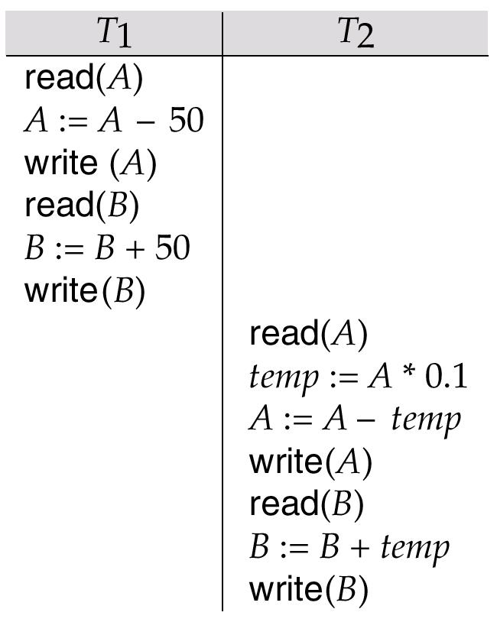
- Schedules – sequences that indicate the chronological order in which instructions of concurrent transactions are executed
  - a schedule for a set of transactions must consist of all instructions of those transactions
  - must preserve the order in which the instructions appear in each individual transaction.
  - Example of schedules (refer right figures)
    - Schedule 1 (right figure): Let T₁ transfer $50 from A to B, and T₂ transfer 10% of the balance from A to B. The following is a serial schedule, in which T₁ is followed by T₂.
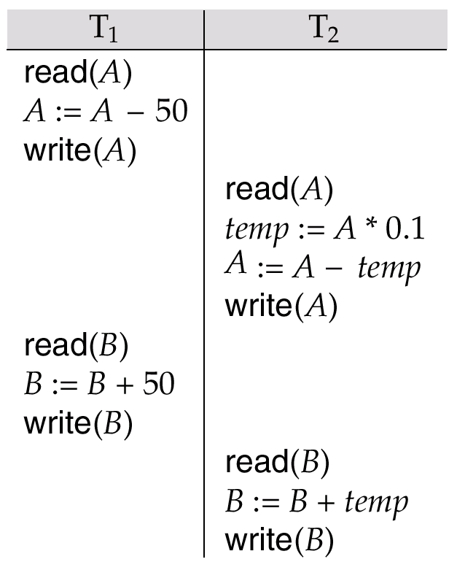
    - Schedule 2 (right figure): Let T₁ and T₂ be the transactions defined previously. The following schedule is not a serial schedule, but it is equivalent to Schedule 1.
    - Schedule 3 (lower right figure): The following concurrent schedule does not preserve the value of the sum A + B.
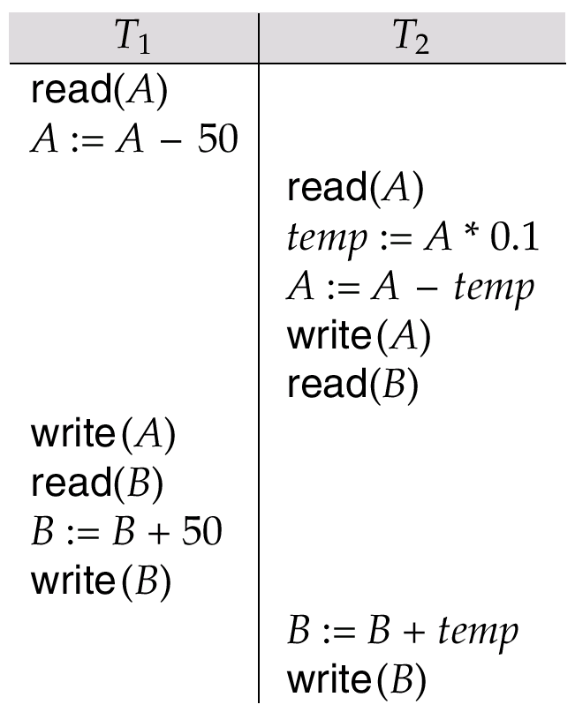
          - Serializability – A (possibly concurrent) schedule is serializable if it is equivalent to a serial schedule. Different forms of schedule equivalence give rise to the notions of:
1. conflict serializability
2. view serializability
        - Conflict Serializability: Instructions l_{i} and l_{j} of transactions T_{i} and T_{j} respectively, conflict if and only if there exists some item Q accessed by both l_{i} and l_{j}, and at least one of these instructions wrote Q.
            - I_{i} = read(Q), I_{j} = read(Q). I_{i} and I_{j} don’t conflict.
            - I_{i} = read(Q), I_{j} = write(Q). They conflict.
            - I_{i} = write(Q), I_{j} = read(Q). They conflict
            - I_{i} = write(Q), I_{j} = write(Q). They conflict
- If a schedule S can be transformed into a schedule S’ by a series of swaps of non-conflicting instructions, we say that S and S’ are conflict equivalent.
- We say that a schedule S is conflict serializable if it is conflict equivalent to a serial schedule.
              - View Serializability: Let S and S´ be two schedules with the same set of transactions. S and S´ are view equivalent if the following three conditions are met:
- For each data item Q, if transaction T_{i} reads the initial value of Q in schedule S, then transaction T_{i} must, in schedule S’, also read the initial value of Q.
- For each data item Q if transaction T_{i} executes read(Q) in schedule S, and that value was produced by transaction T_{j} (if any), then transaction T_{i} must in schedule S´ also read the value of Q that was produced by transaction T_{j}.
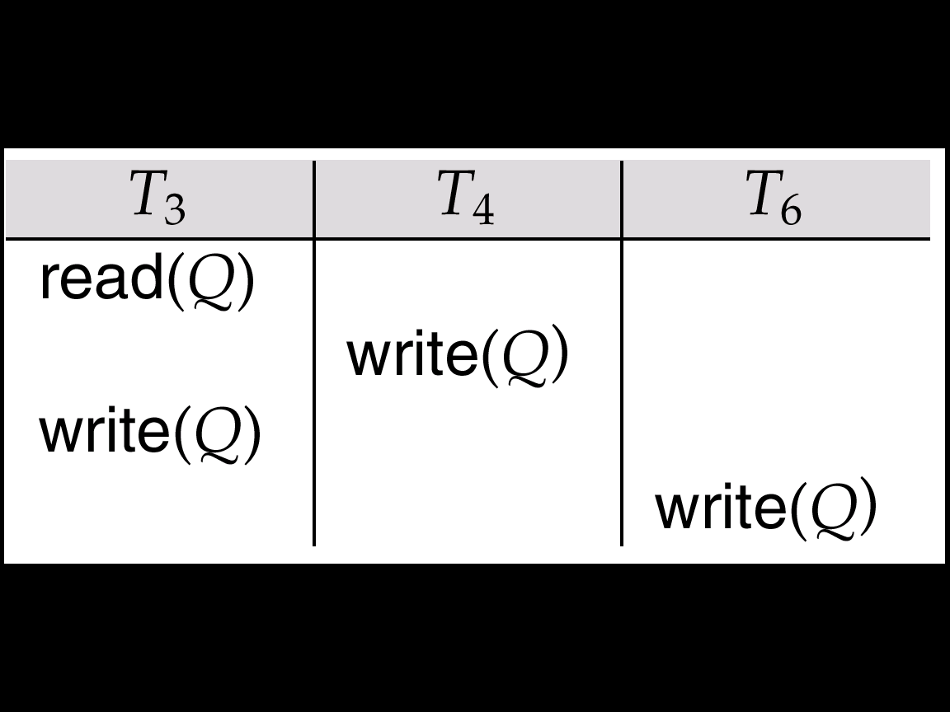
- For each data item Q, the transaction (if any) that performs the final write(Q) operation in schedule S must perform the final write(Q) operation in schedule S’.
            - As can be seen, view equivalence is also based purely on reads and writes alone.
            - A schedule S is view serializable it is view equivalent to a serial schedule.
            - Every conflict serializable schedule is also view serializable.
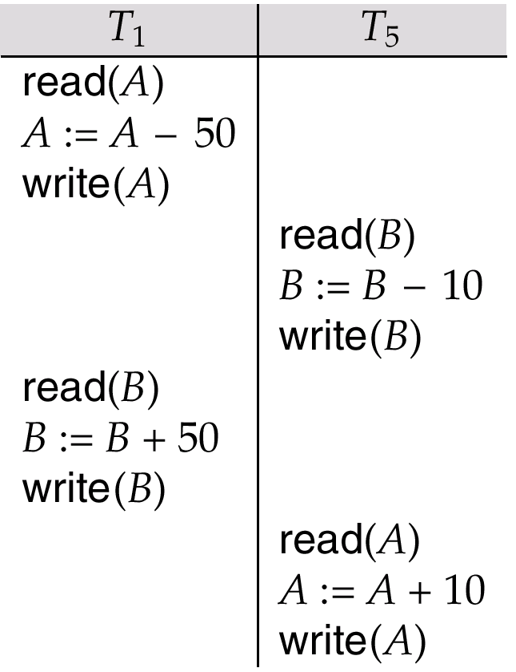
            - Schedule in right figure – a schedule which is view-serializable but not conflict serializable.
            - Every view serializable schedule that is not conflict serializable has blind writes.
              - Other Notions of Serializability
      - Schedule in right figure given below produces same outcome as the serial schedule < T₁, T₅ >, yet is not conflict equivalent or view equivalent to it.
      - Determining such equivalence requires analysis of operations other than read and write.
          - Recoverability – Need to address the effect of transaction failures on concurrently running transactions
- Recoverable schedule – if a transaction T_{j} reads a data items previously written by a transaction T_{i}, the commit operation of T_{i} appears before the commit operation of T_{j}.
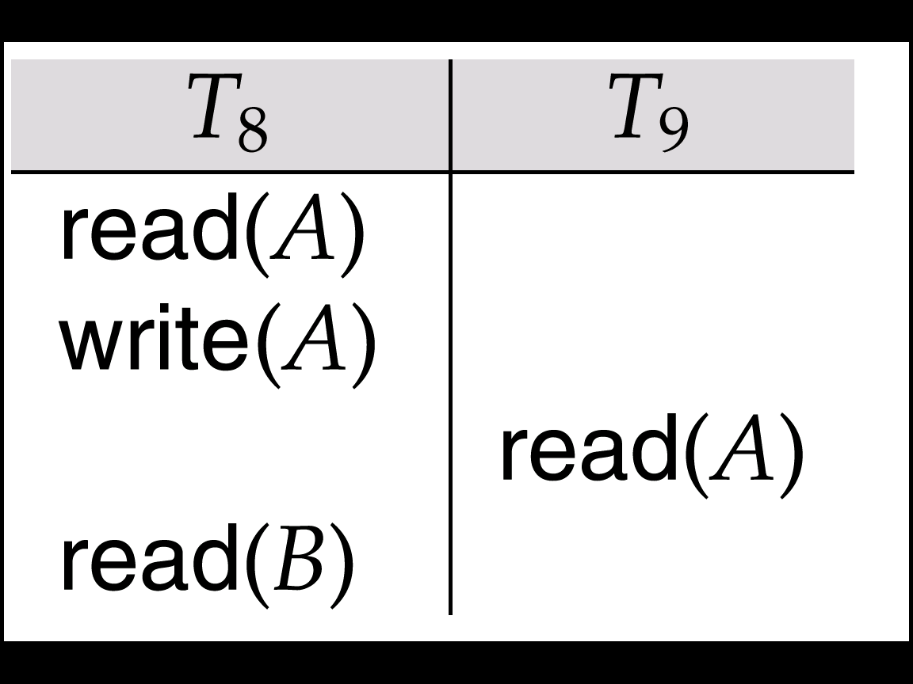
- The schedule in right figure is not recoverable if T₉ commits immediately after the read.
- If T₈ should abort, T₉ would have read (and possibly shown to the user) an inconsistent database state. Hence database must ensure that schedules are recoverable.
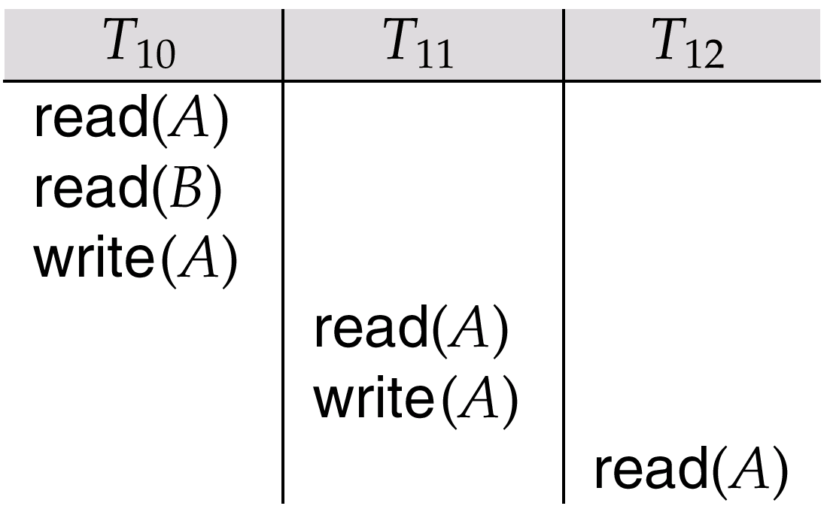
  - Cascading rollback – a single transaction failure leads to a series of transaction rollbacks. Consider the following schedule where none of the transactions has yet committed (so the schedule is recoverable)
    - If T₁₀ fails, T₁₁ and T₁₂ must also be rolled back.
    - Can lead to the undoing of a significant amount of work
  - Cascadeless schedules — cascading rollbacks cannot occur; for each pair of transactions T_{i} and T_{j} such that T_{j} reads a data item previously written by T_{i}, the commit operation of T_{i} appears before the read operation of T_{j}.
    - Every cascadeless schedule is also recoverable
    - It is desirable to restrict the schedules to those that are cascadeless
      - Implementation of Isolation
        - Schedules must be conflict or view serializable, and recoverable, for the sake of database consistency, and preferably cascadeless.
        - A policy in which only one transaction can execute at a time generates serial schedules, but provides a poor degree of concurrency.
        - Concurrency-control schemes tradeoff between the amount of concurrency they allow and the amount of overhead that they incur.
        - Some schemes allow only conflict-serializable schedules to be generated, while others allow view-serializable schedules that are not conflict-serializable.

Concurrency Control with Locking Methods
- Lock guarantees current transaction exclusive use of data item, i.e., transaction T2 does not have access to a data item that is currently being used by transaction T1.
- Acquires lock prior to access.
- Lock released when transaction is completed.
- DBMS automatically initiates and enforces locking procedures.
- All lock information is managed by lock manager.

Lock Granularity
  - Lock granularity indicates level of lock use: database, table, page, row, or field (attribute).

Database-Level
  - The entire database is locked.
  - Transaction T2 is prevented to use any tables in the database while T1 is being executed.
  - Good for batch processes, but unsuitable for online multi-user DBMSs.
  - Refer Figure 2, transactions T1 and T2 cannot access the same database concurrently, even if they use different tables. (The access is very slow!)

Table-Level
  - The entire table is locked. If a transaction requires access to several tables, each table may be locked.
  - Transaction T2 is prevented to use any row in the table while T1 is being executed.
  - Two transactions can access the same database as long as they access different tables.
  - It causes traffic jams when many transactions are waiting to access the same table.
  - Table-level locks are not suitable for multi-user DBMSs.
  - Refer Figure 3, transaction T1 and T2 cannot access the same table even if they try to use different rows; T2 must wait until T1 unlocks the table.

Page-Level
  - The DBMS will lock an entire diskpage (or page), which is the equivalent of a diskblock as a (referenced) section of a disk.
  - A page has a fixed size and a table can span several pages while a page can contain several rows of one or more tables.
  - Page-level lock is currently the most frequently used multi-user DBMS locking method.
  - Figure 4 shows that T1 and T2 access the same table while locking different diskpages.
  - T2 must wait for using a locked page which locates a row, if T1 is using it.

Row-Level
  - With less restriction respect to previous discussion, it allows concurrent transactions to access different rows of the same table even if the rows are located on the same page.
  - It improves the availability of data, but requires high overhead cost for management.
  - Refer Figure 5 for row-level lock.

Field-Level
- It allows concurrent transactions to access the same row, as long as they require the use of different fields (attributes) within a row.
- The most flexible multi-user data access, but cost extremely high level of computer overhead.

Lock Types
- The DBMS may use different lock types: binary or shared/exclusive locks.
- A locking protocol is a set of rules followed by all transactions while requesting and releasing locks. Locking protocols restrict the set of possible schedules.

Binary Locks
- Two states: locked (1) or unlocked (0).
- Locked objects are unavailable to other objects.
- Unlocked objects are open to any transaction.
- Transaction unlocks object when complete.
- Every transaction requires a lock and unlock operation for each data item that is accessed.

Table 10 Example of Binary Lock Table
Note: the lock and unlock features eliminate the lost update problem encountered in table 3. However, binary locks are now considered too restrictive to yield optimal concurrency conditions.

Shared/Exclusive Locks
  - Shared (S Mode)
- Exists when concurrent transactions granted READ access
- Produces no conflict for read-only transactions
- Issued when transaction wants to read and exclusive lock not held on item
  - Exclusive (X Mode)
- Exists when access reserved for locking transaction
- Used when potential for conflict exists (also refer Table 9)
- Issued when transaction wants to update unlocked data
  - Lock-compatibility matrix
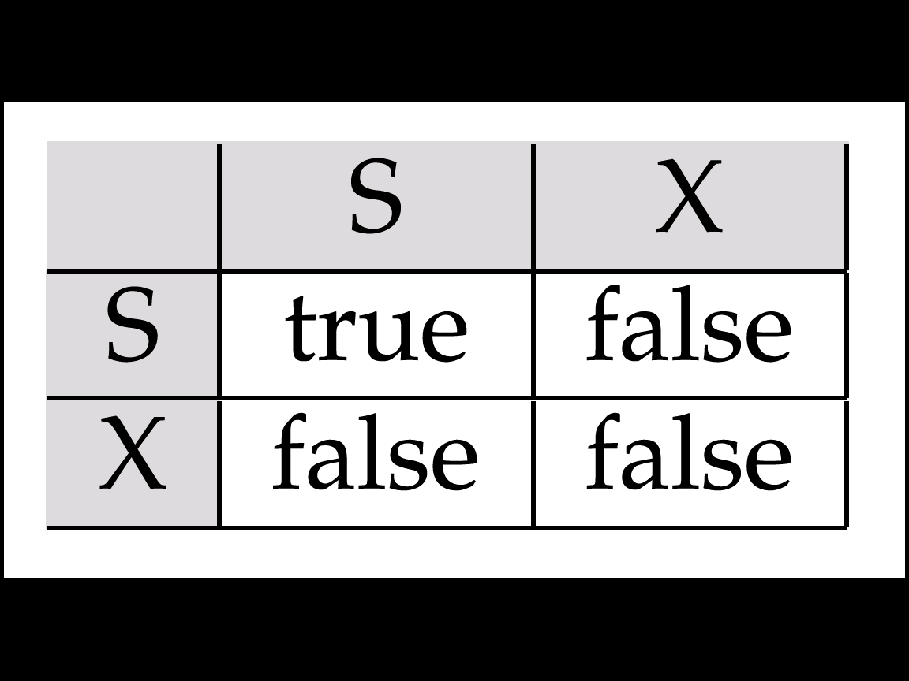
    - A transaction may be granted a lock on an item if the requested lock is compatible with locks already held on the item by other transactions
    - Any number of transactions can hold shared locks on an item, but if any transaction holds an exclusive on the item no other transaction may hold any lock on the item.
    - If a lock cannot be granted, the requesting transaction is made to wait till all incompatible locks held by other transactions have been released. The lock is then granted.
  - Reasons to increasing manager’s overhead
    - The type of lock held must be known before a lock can be granted
    - Three lock operations exist: READ_LOCK (to check the type of lock), WRITE_LOCK (to issue the lock), and UNLOCK (to release the lock).
    - The schema has been enhanced to allow a lock upgrade (from shared to exclusive) and a lock downgrade (from exclusive to shared).
  - Problems with Locking
    - Transaction schedule may not be serializable
      - Managed through two-phase locking
    - Schedule may create deadlocks
      - Managed by using deadlock detection and prevention techniques

Two-Phase Locking
        - Two-phase locking defines how transactions acquire and relinquish (or revoke) locks.
          - Growing phase – acquires all the required locks without unlocking any data. Once all locks have been acquired, the transaction is in its locked point.
          - Shrinking phase – releases all locks and cannot obtain any new lock.
            - Governing rules
              - Two transactions cannot have conflicting locks
              - No unlock operation can precede a lock operation in the same transaction
              - No data are affected until all locks are obtained
                - In the example for two-phase locking protocol (Figure 6), the transaction acquires all the locks it needs (two locks are required) until it reaches its locked point.
- When the locked point is reached, the data are modified to conform to the transaction requirements.
- The transaction is completed as it released all of the locks it acquired in the first phase.
- Updates for two-phase locking protocols:
  - Two-phase locking does not ensure freedom from deadlocks.
  - Cascading roll-back is possible under two-phase locking. To avoid this, follow a modified protocol called strict two-phase locking. Here a transaction must hold all its exclusive locks till it commits/aborts.
  - Rigorous two-phase locking is even stricter: here all locks are held till commit/abort. In this protocol transactions can be serialized in the order in which they commit.
  - There can be conflict serializable schedules that cannot be obtained if two-phase locking is used.
  - However, in the absence of extra information (e.g., ordering of access to data), two-phase locking is needed for conflict serializability in the following sense:
Given a transaction T_{i} that does not follow two-phase locking, we can find a transaction T_{j} that uses two-phase locking, and a schedule for T_{i} and T_{j} that is not conflict serializable.

Deadlocks
  - Occurs when two transactions wait for each other to unlock data. For example:
T1 = access data items X and Y
T2 = access data items Y and X
    - Deadly embrace – if T₁ has not unlocked data item Y, T₂ cannot begin; if T₂ has not unlocked data item X, T₁ cannot continue. (Refer Table 11.)
    - Starvation is also possible if concurrency control manager is badly designed.
      - For example, a transaction may be waiting for an X-lock (exclusive mode) on an item, while a sequence of other transactions request and are granted an S-lock (shared mode) on the same item.
      - The same transaction is repeatedly rolled back due to deadlocks.
    - Control techniques
      - Deadlock prevention – a transaction requesting a new lock is aborted if there is the possibility that a deadlock can occur.
      - If the transaction is aborted, all the changes made by this transaction are rolled back, and all locks obtained by the transaction are released.
      - It works because it avoids the conditions that lead to deadlocking.
      - Deadlock detection – the DBMS periodically tests the database for deadlocks.
      - If a deadlock is found, one of the transactions (the “victim”) is aborted (rolled back and restarted), and the other transaction continues.
      - Deadlock avoidance – the transaction must obtain all the locks it needs before it can be executed.
      - The technique avoids rollback of conflicting transactions by requiring that locks be obtained in succession.
      - The serial lock assignment required in deadlock avoidance increase action response times.
- Control Choices
  - If the probability of deadlocks is low, deadlock detection is recommended.
  - If the probability of deadlocks is high, deadlock prevention is recommended.
  - If response time is not high on the system priority list, deadlock avoidance might be employed.

Implementation of Locking
- A Lock manager can be implemented as a separate process to which transactions send lock and unlock requests
- The lock manager replies to a lock request by sending a lock grant messages (or a message asking the transaction to roll back, in case of a deadlock)
- The requesting transaction waits until its request is answered
- The lock manager maintains a datastructure called a lock table to record granted locks and pending requests
- The lock table is usually implemented as an in-memory hash table indexed on the name of the data item being locked
- Lock Table
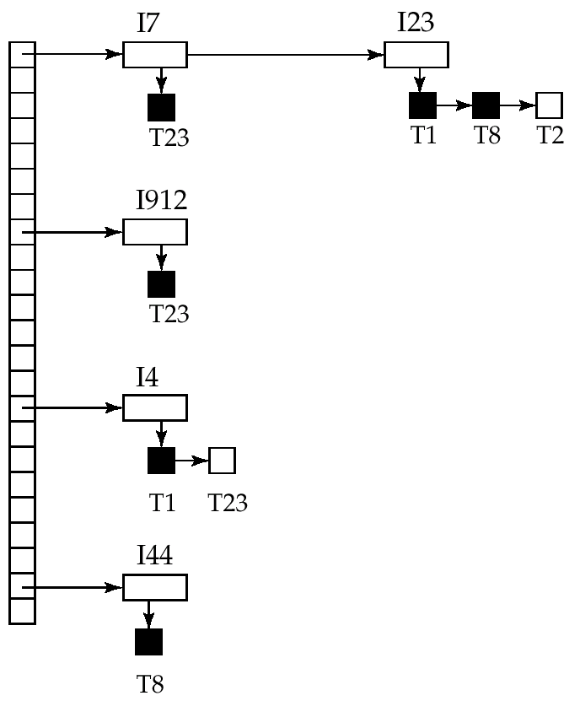
  - Black rectangles indicate granted locks, white ones indicate waiting requests
  - Lock table also records the type of lock granted or requested
  - New request is added to the end of the queue of requests for the data item, and granted if it is compatible with all earlier locks
  - Unlock requests result in the request being deleted, and later requests are checked to see if they can now be granted
  - If transaction aborts, all waiting or granted requests of the transaction are deleted
      - lock manager may keep a list of locks held by each transaction, to implement this efficiently

Concurrency Control with Time Stamping Methods
    - Assigns global unique time stamp to each transaction
    - Produces order for transaction submission
    - Properties
- Uniqueness: ensures that no equal time stamp values can exist.
- Monotonicity: ensures that time stamp values always increase.
  - DBMS executes conflicting operations in time stamp order to ensure serializability of the transaction.
    - If two transactions conflict, one often is stopped, rolled back, and assigned a new time stamp value.
  - Each value requires two additional time stamps fields
    - Last time field read
    - Last update
      - Time stamping tends to demand a lot of system resources because there is a possibility that many transactions may have to be stopped, rescheduled, and re-stamped.

Timestamp-Based Protocols
      - Each transaction is issued a timestamp when it enters the system. If an old transaction T_{i} has time-stamp TS(T_{i}), a new transaction T_{j} is assigned time-stamp TS(T_{j}) such that TS(T_{i}) < TS(T_{j}).
      - The protocol manages concurrent execution such that the time-stamps determine the serializability order.
      - In order to assure such behavior, the protocol maintains for each data Q two timestamp values:
              - W-timestamp(Q) is the largest time-stamp of any transaction that executed write(Q) successfully.
              - R-timestamp(Q) is the largest time-stamp of any transaction that executed read(Q) successfully.
      - The timestamp ordering protocol ensures that any conflicting read and write operations are executed in timestamp order.
      - Suppose a transaction T_{i} issues a read(Q)
            - If TS(T_{i}) ≦ W-timestamp(Q), then T_{i} needs to read a value of Q that was already overwritten. Hence, the read operation is rejected, and T_{i} is rolled back.
            - If TS(T_{i}) ≧ W-timestamp(Q), then the read operation is executed, and R-timestamp(Q) is set to the maximum of R-timestamp(Q) and TS(T_{i}).
- Suppose that transaction T_{i} issues write(Q).
                - If TS(T_{i}) < R-timestamp(Q), then the value of Q that T_{i} is producing was needed previously, and the system assumed that that value would never be produced. Hence, the write operation is rejected, and T_{i} is rolled back.
                - If TS(T_{i}) < W-timestamp(Q), then T_{i} is attempting to write an obsolete value of Q. Hence, this write operation is rejected, and Ti is rolled back.
                - Otherwise, the write operation is executed, and W-timestamp(Q) is set to TS(T_{i}).

Concurrency Control with Optimistic Methods
- A validation-based protocol that assumes most database operations do not conflict.
- No requirement on locking or time stamping techniques.
- Transaction executed without restrictions until committed and fully in the hope that all will go well during validation.
- Two or three Phases:
  - Read (and Execution) Phase – the transaction reads the database, executes the needed computations, and makes the updates to a private copy of the database values.
  - Validation Phase – the transaction is validated to ensure that the changes made will not affect the integrity and consistency of the database.
  - Write Phase – the changes are permanently applied to the database.
- The optimistic approach is acceptable for mostly read or query database system that require very few update transactions.
- Each transaction T_{i} has 3 timestamps
  - Start(T_{i}) : the time when T_{i} started its execution
  - Validation(T_{i}): the time when T_{i} entered its validation phase
  - Finish(T_{i}): the time when T_{i} finished its write phase
- Serializability order is determined by timestamp given at validation time, to increase concurrency. Thus TS(T_{i}) is given the value of Validation(T_{i}).
- This protocol is useful and gives greater degree of concurrency if probability of conflicts is low. That is because the serializability order is not pre-decided and relatively less transactions will have to be rolled back.

Database Recovery Management
- Restores a database to previously consistent state, usually inconsistent, to a previous consistent state.
- Based on the atomic transaction property: all portions of the transaction must be treated as a single logical unit of work, in which all operations must be applied and completed to produce a consistent database.
- Level of backup
  - Full backup – dump of the database.
  - Differential backup – only the last modifications done to the database are copied.
  - Transaction log – only the transaction log operations that are not reflected in a previous backup copy of the database.
- The database backup is stored in a secure place, usually in a different building, and protected against dangers such as file, theft, flood, and other potential calamities.
- Causes of Database Failure
  - Software – be traceable to the operating system, the DBMS software, application programs, or virus.
  - Hardware – include memory chip errors, disk crashes, bad disk sectors, disk full errors.
  - Programming Exemption – application programs or end users may roll back transactions when certain conditions are defined.
  - Transaction – the system detects deadlocks and aborts one of the transactions.
  - External – a system suffers complete destruction due to fire, earthquake, flood, etc.

Transaction Recovery
    - Four important concepts to affect recovery process –
        - Write-ahead-log protocol – ensures that transaction logs are always written before any database data are actually updated.
        - Redundant transaction logs – ensure that a disk physical failure will not impair the DBMS ability to recover data.
        - Database buffers – create temporary storage area in primary memory used to speed up disk operations and improve processing time.
        - Database checkpoint – setup an operation in which the DBMS writes all of its updated buffers to disk and registered in the transaction log.
    - Transaction recovery procedure generally make use of deferred-write and write-through techniques.
        - Deferred-write (or Deferred-update)
      - Changes are written to the transaction log, not physical database.
      - Database updated after transaction reaches commit point.
      - Steps:
            - Identify the last checkpoint in the transaction log. This is the last time transaction data was physically saved to disk.
            - For a transaction that started and committed before the last checkpoint, nothing needs to be done, because the data are already saved.
            - For a transaction that performed a commit operation after the last checkpoint, the DBMS uses the transaction log records to redo the transaction and to update the database, using “after” values in the transaction log. The changes are made in ascending order, from the oldest to the newest.
            - For any transaction with a RP::BACK operation after the last checkpoint or that was left active (with neither a COMMIT nor a ROLLBACK) before the failure occurred, nothing needs to be done because the database was never updated.
  - Write-through (or immediate update)
      - Immediately updated by during execution
      - Before the transaction reaches its commit point
      - Transaction log also updated
      - Transaction fails, database uses log information to ROLLBACK
      - Steps:
- Identify the last checkpoint in the transaction log. This is the last time transaction data was physically saved to disk.
- For a transaction that started and committed before the last checkpoint, nothing needs to be done, because the data are already saved.
- For a transaction that committed after the last checkpoint, the DBMS redoes the transaction, using “after” values in the transaction log. Changes are applied in ascending order, from the oldest to the newest.
- For any transaction with a ROLLBACK operation after the last checkpoint or that was left active (with neither a COMMIT nor a ROLLBACK) before the failure occurred, the DBMS uses the transaction log records to ROLLBACK or undo the operations, using the “before” values in the transaction log. Changes are applied in reverse order, from the newest to the oldest.

